**Summary of Results for Moderate**

**2016**

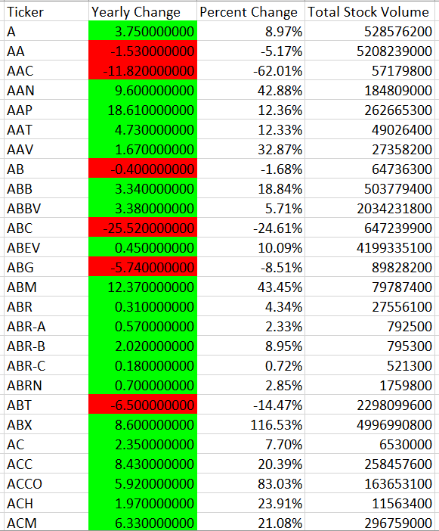

**2015**

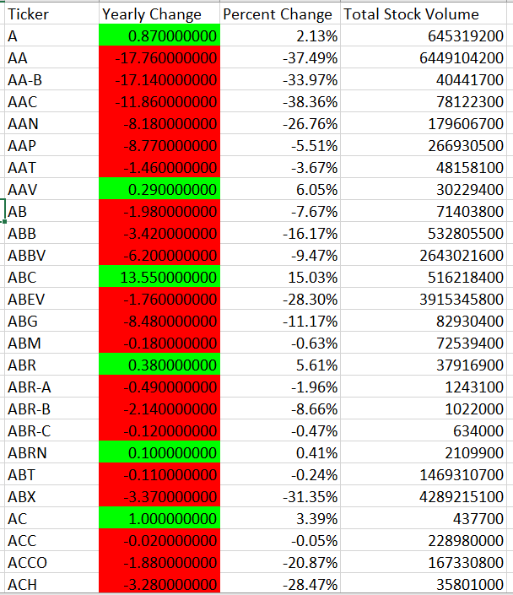

**2014**

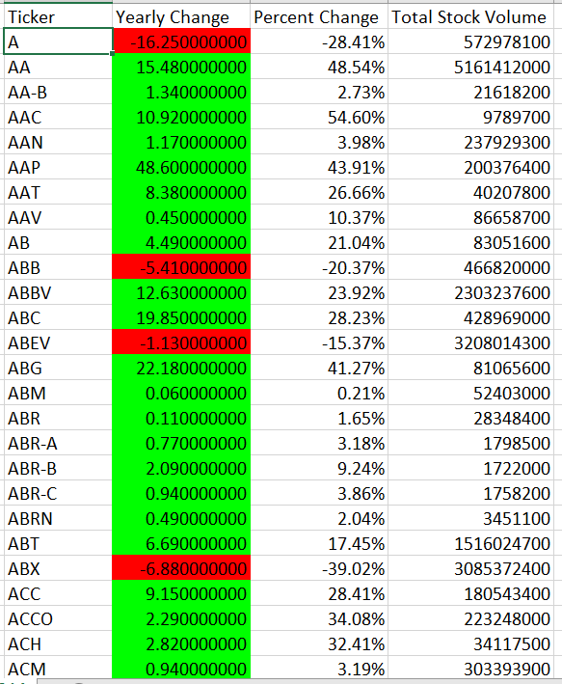

**Summary of Results for Hard**

**2016**

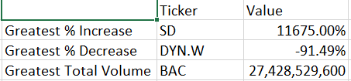

**2015**

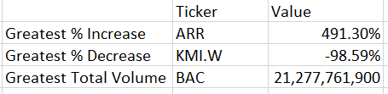

**2014**

